10 February 2026

Re: Willow Park School – Leadership Update

Dear Parents and Carers,

As you will know, Mark Fairbrother was seconded to Stubbin Wood School as Interim Principal in order to bring stability to that school and provide consistency through experienced leadership.

With Stubbin Wood making progress, it is now time for Mark to return to his substantive post as Principal of Willow Park School. Please join us in welcoming Mark back to the school, following the half term break.

Please also join us in thanking Jake Bower for taking on the leadership of Willow Park school in Mark’s absence, for his commitment to raising standards, and his dedication to the pupils, staff and wider school community. After half term Jake will revert back to his substantive post as Deputy Headteacher, and will work alongside Mark to continue improving the quality of education at Willow Park School for all pupils.

Have a safe and enjoyable half term break.

Yours faithfully
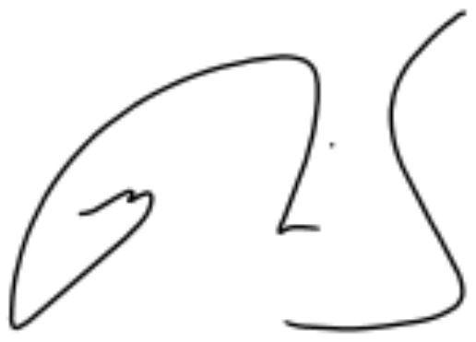

Matt Morris
Interim Chief Executive Officer

